**Dictionary:**

#dictionary in python

countryCity = {"Pakistan": "Karachi","Turkey": "Istanbul", "Japan": "Tokyo","England": "London"}

print(countryCity)

#inserting element in dictionary

countryCity["Sri Lanka"] = "Colombo"

#updating dictionary

countryCity["Pakistan"] = "Islamabad"

print(countryCity)

#deleting element from dictionary

del countryCity["Japan"]

print(countryCity)

#sorting dictionary elements

sortedList = sorted(countryCity)

print("sorted list is")

print(sortedList)

#getting all only keys of dictionaries

countryCity.keys()

print(countryCity)

#deleting whole dictionary

countryCity.clear();

print(countryCity)

**Taking input in data structures and printing them:**

#implementation of function in python and printing tuple, set, dictionary, list by taking input from users

print("1-Insert in List   2-Insert in Set   3-Insert in Tuple    4-Insert in Dictionary")

choice = int(input("Enter your choice from above: "))

numberOfElements = int(input("Enter number of elements you want to insert: "))

List = ["Apple"]

Tuple = ()

Set = {}

Dictionary = {}

if(choice==1):

  for x in range(numberOfElements):

    element = input("Enter element: ")

    List.append(element)

  print(List)

elif(choice==2):

  for x in range(numberOfElements):

    element = input("Enter element: ")

    Set.add(element)

  print(Set)

elif(choice==3):

  for x in range(numberOfElements):

    element = input("Enter element: ")

    Tuple = Tuple + (element,)

  print(Tuple)

elif(choice==4):

  for x in range(numberOfElements):

    element = input("Enter element: ")

    Dictionary[x] = element

  print(Dictionary)

def printDataStructures():

  if(choice==1):

    print("List is: ", List)

  elif(choice==2):

    print("Set is: " , Set)

  elif(choice==3):

    print("Tuple is: " , Tuple)

  elif(choice==4):

    print("Dictionary is: " , Dictionary)

printDataStructures()

**CRUD operations on All Data Structures:**

**Set:**

#CRUD on set

Set = {0,12,3}

print(Set)

print("1-Insert   2-Delete   3-Update   4-Read")

choice = int(input("Enter your choice: "))

if(choice==1):

  element = int(input("Enter element: "))

  Set.add(element)

  print(Set)

elif(choice==2):

  element = int(input("Enter element you want to delete: "))

  for element in Set:

    if(element):

      Set.discard(element)

  print(Set)

elif(choice==3):

  element = int(input("Enter element you want to update: "))

  new = int(input("Enter new element: "))

  Set.remove(element)

  Set.add(new)

  print(Set)

elif(choice==4):

  element = int(input("Enter element you want to update: "))

  for element in Set:

    print("element found")

  print(Set)

**List:**

#CRUD on List

List = ['ahmad','rehan']

print(List)

print("1-Insert   2-Delete   3-Update   4-Read")

choice = int(input("Enter your choice: "))

if(choice==1):

  element = input("Enter element: ")

  List.append(element)

  print(List)

elif(choice==2):

  element = input("Enter element you want to delete: ")

  List.remove(element)

  print(List)

elif(choice==3):

  element = input("Enter element you want to update: ")

  index = 0

  if element in List:

    index = List.index(element)

  new = input("Enter new element: ")

  List[index] = new

  print(List)

elif(choice==4):

  element = input("Enter element you want to update: ")

  if element in List:

    print("element found")

  print(List)

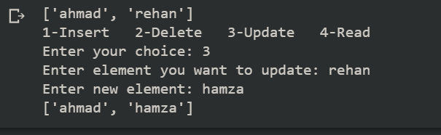

**Dictionary**:

#CRUD on Dictionary

Dictionary = {"England": "London"}

print(Dictionary)

print("1-Insert   2-Delete   3-Update   4-Read")

choice = int(input("Enter your choice: "))

if(choice==1):

  key = input("Enter key: ")

  value = input("Enter value of key: ")

  Dictionary[key] = value

  print(Dictionary)

elif(choice==2):

  key = input("Enter key you want to delete: ")

  del Dictionary[key]

  print(Dictionary)

elif(choice==3):

  key = input("Enter key whose value you want to update: ")

  value = input("Enter new value: ")

  Dictionary[key] = value

  print(Dictionary)

elif(choice==4):

  element = input("Enter key you want to search: ")

  if element in Dictionary:

    print("Element found")

  else:

    print("Element not found - check spellings")

  print(Dictionary)

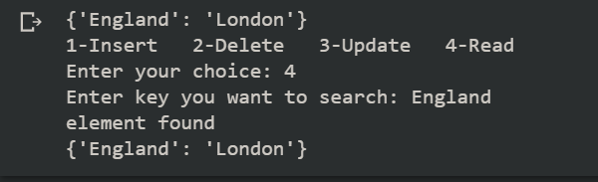

**Tuple**:

**Merging in all Data Structures:**

#merging sets

Set1 = {1,2,3}

Set2 = {4,5,6}

Set3 = Set1.union(Set2)

print(Set3)

#merging Tuples

T1 = (1,2,3)

T2 = (4,5,6)

T3 = T1 + T2

print(T3)

#merging Lists

L1 = [1,2,3]

L2 = [4,5,6]

L1.extend(L2)

print(L1)

#merging Dictionaries

D1 = {1:'ahmad',2:'rashid'}

D2 = {3:'rehan',4:'khan'}

D1.update(D2)

print(D1)

